**San Francisco Bay University**

**CE521 - Real-time Systems and Programming**

**Homework Assignment #4**

**Due day: 3/7/2022**

**Student ID: 19590**

**Instruction:**

1. **Push the answer sheet to Github**
2. **Overdue homework submission could not be accepted.**
3. **Takes academic honesty and integrity seriously (Zero Tolerance of Cheating & Plagiarism)**
4. Install *SystemView* to your computer following the instructions in Lab2 manual
5. Get familiar with the trace tool *SystemView* following the instructions in the lab3 manuals

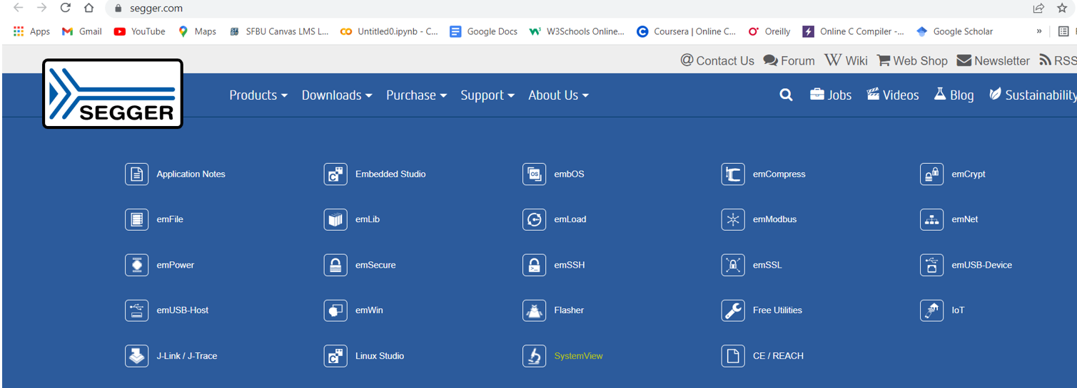

1. Complete the question in the lab assignment of lab3 manuals

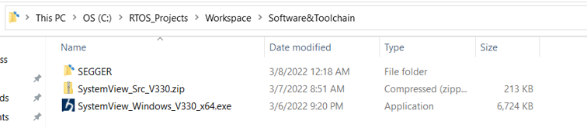

* When #define configUSE_TIMERS 0 is set 1, the timer is set or activated. Scheduler is started when configUSE timer is set to 1.